# How to use IIS as a Reverse proxy server

There is a situation that you have hosted app on a server which is not accessible to real world. To make it accessible to real world, you can use IIS as a reverse proxy server and all incoming traffic from internet can be forwarded to backend server on your private network.

To setup IIS for reverse proxy scenario, you have to install add-on module called URL rewrite. You can download that extension from <https://www.iis.net/downloads/microsoft/url-rewrite>

Once the module is installed on IIS, you can see a new icon URL Rewrite is displayed in IIS Administrator Console. This Icon is available for each web application.

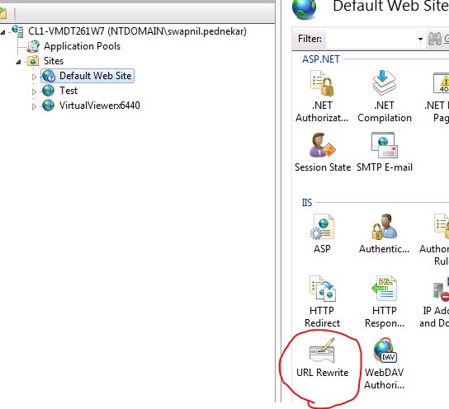

# Steps to setup reverse proxy.

1. Open IIS and select web application.
2. Select the URL Rewrite Icon from the middle pane and double click on it.
3. Choose the Add Rule action from the right pane.

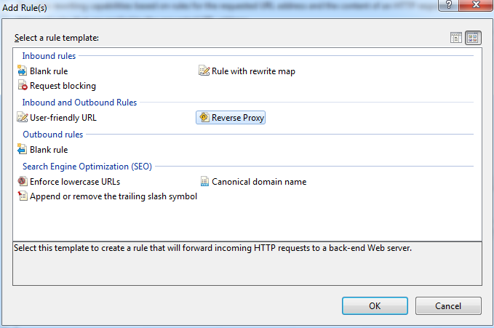

1. Select Reverse Proxy from Inbound and Outbound Rules section. Now in "Add Reverse proxy Rules" window, enter the name of your private server with port number. For Eg. CL1-VMTS2WEB:01:127.

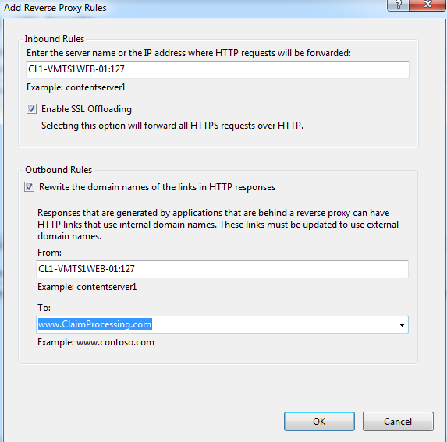

1. Select Enable SSL Offloading.
2. In outbound Rule, select Rewrite the domain names of the links in HTTP responses checkbox.
3. From textbox will be populated. Mention public url name in to textbox.
4. Click OK and APPly Rule.

Now all request to your website will be forwarded to CL1-VMTS2WEB-01 server on port 127